**CSS EXPERIMENT 9**

1. Baseline Network Scan with Nmap

nmap -sn 192.168.0.0/24

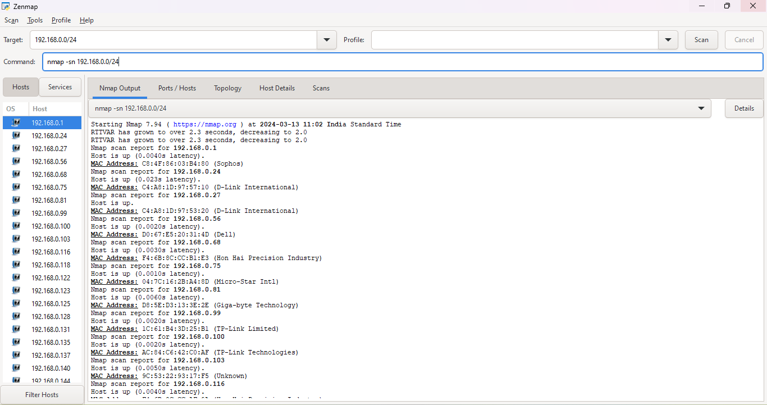

1. Capture Network Traffic with Wireshark

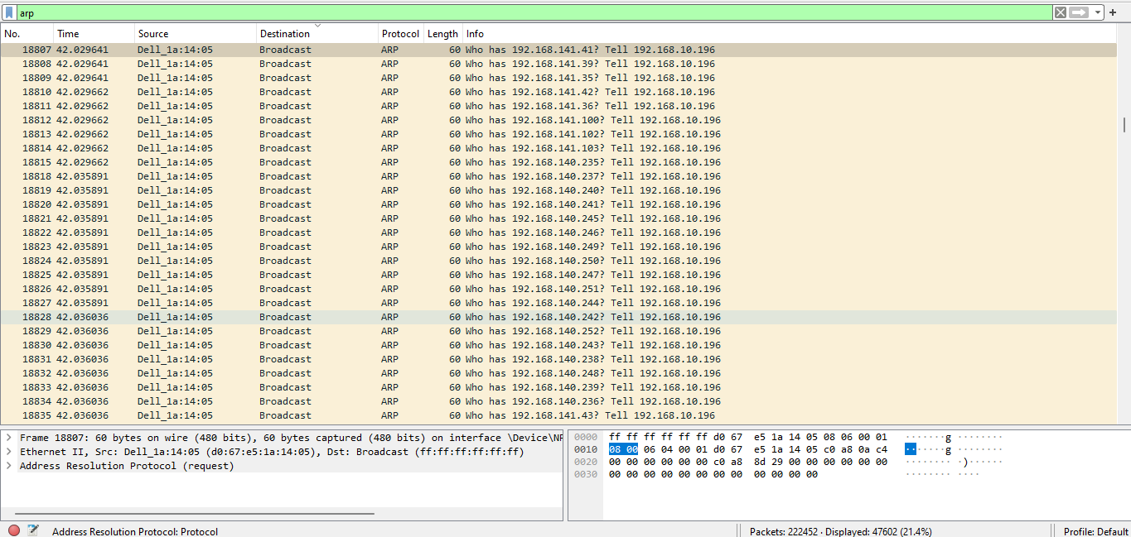

1. Generate ARP Spoofing Traffic

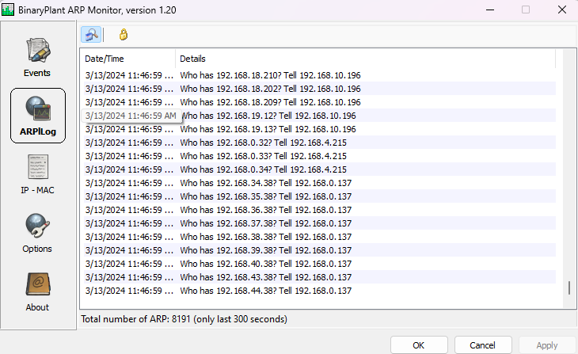

1. Use Nmap for ARP Scanning:

